1. What is the 48-bit Ethernet address of your computer?

00:90:7f:d1:6a:0b

1. What is the 48-bit destination address in the Ethernet frame? Is this the Ethernet address of gaia.cs.umass.edu? (Hint: the answer is no). What device has this as its Ethernet address? [Note: this is an important question, and one that students sometimes get wrong. Re-read pages 468-469 in the text and make sure you understand the answer here.]

The address is d8:9e:f3:14:be:6f:00:90 which is not the address of the website but the address of the firewall that’s doing the routing.

1. Give the hexadecimal value for the two-byte Frame type field. What upper layer protocol does this correspond to?

The hex value for the frame type field is 0x800 which is the IP protocol.

1. How many bytes from the very start of the Ethernet frame does the ASCII “G” in “GET” appear in the Ethernet frame?

52 bytes from the start header. 2o bytes of TCP header prior to HTTP data.

1. What is the value of the Ethernet source address? Is this the address of your computer, or of gaia.cs.umass.edu (Hint: the answer is no). What device has this as its Ethernet address?

Neither it’s the address of my firewall. This is the same question as 2.

1. What is the destination address in the Ethernet frame? Is this the Ethernet address of your computer?

00:90:7f:d1:6a:0b that’s the destination address which is my PC.

1. Give the hexadecimal value for the two-byte Frame type field. What upper layer protocol does this correspond to?

The field contains 0x800 which means the IP protocol

1. How many bytes from the very start of the Ethernet frame does the ASCII “O” in “OK” (i.e., the HTTP response code) appear in the Ethernet frame?

The O is 52 bytes from the start. Another 54 bytes before you see HTTP data

1. Write down the contents of your computer’s ARP cache. What is the meaning of each column value?

The internet Address is the IP of the device, the Physical Address is the MAC and the Type is the protocol its using.

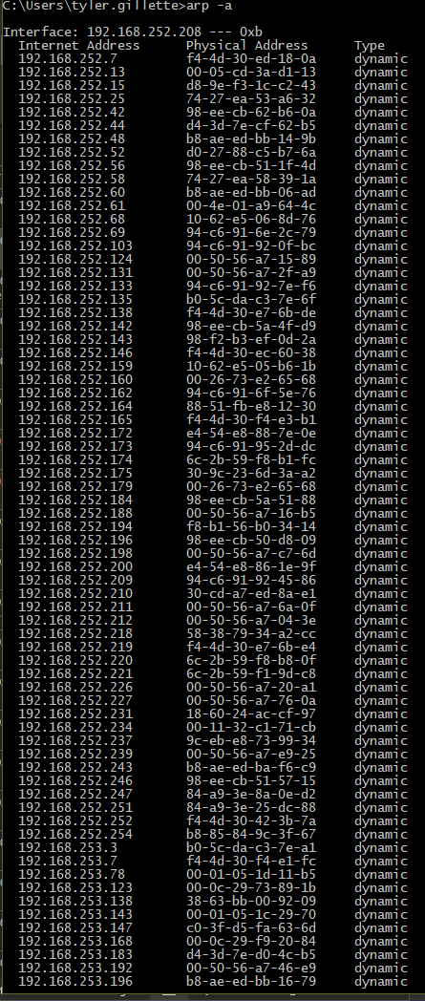

1. What are the hexadecimal values for the source and destination addresses in the Ethernet frame containing the ARP request message?

00:d0:59:a9:3d:68 is the source and the destination address is ff:ff:ff:ff:ff:ff

1. Give the hexadecimal value for the two-byte Ethernet Frame type field. What upper layer protocol does this correspond to?

0x806 which stands for ARP

1. Download the ARP specification from ftp://ftp.rfc-editor.org/in-notes/std/std37.txt. A readable, detailed discussion of ARP is also at http://www.erg.abdn.ac.uk/users/gorry/course/inet-pages/arp.html.
   1. How many bytes from the very beginning of the Ethernet frame does the ARP opcode field begin?

The ARP begins at 20 bytes

* 1. What is the value of the opcode field within the ARP-payload part of the Ethernet frame in which an ARP request is made?

The ARP-Payload is 0x0001

* 1. Does the ARP message contain the IP address of the sender?

The IP address contains 192.168.252.208

* 1. Where in the ARP request does the “question” appear – the Ethernet address of the machine whose corresponding IP address is being queried?

Target MAC Address is 00:00:00:00:00:00

1. Now find the ARP reply that was sent in response to the ARP request.
   1. How many bytes from the very beginning of the Ethernet frame does the ARP opcode field begin?

The ARP code starts at 20 bytes

* 1. What is the value of the opcode field within the ARP-payload part of the Ethernet frame in which an ARP response is made?

ARP-Payload is 0x0002

* 1. Where in the ARP message does the “answer” to the earlier ARP request appear – the IP address of the machine having the Ethernet address whose corresponding IP address is being queried?

Sender Address has 00:90:7f:d1:6a:0b and 192.168.252.208

1. What are the hexadecimal values for the source and destination addresses in the Ethernet frame containing the ARP reply message?

The source is 00:90:7f:d1:6a:0b and the destination is 00:d0:59:a9:3d:68

1. Open the ethernet-ethereal-trace-1 trace file in http://gaia.cs.umass.edu/wireshark-labs/wireshark-traces.zip. The first and second ARP packets in this trace correspond to an ARP request sent by the computer running Wireshark, and the ARP reply sent to the computer running Wireshark by the computer with the ARP-requested Ethernet address. But there is yet another computer on this network, as indicated by packet 6 – another ARP request. Why is there no ARP reply (sent in response to the ARP request in packet 6) in the packet trace?

There is no reply. The ARP reply is sent back to the senders ethernet address.